**Performed by:**

**Saurabh Jadhav : 192010045**

**Trupti Tekawade : 192011063**

**Shriram Bhagwatkar : 192010051**

Experiment No.9: Implementation: DB & System Integration

Admin Login



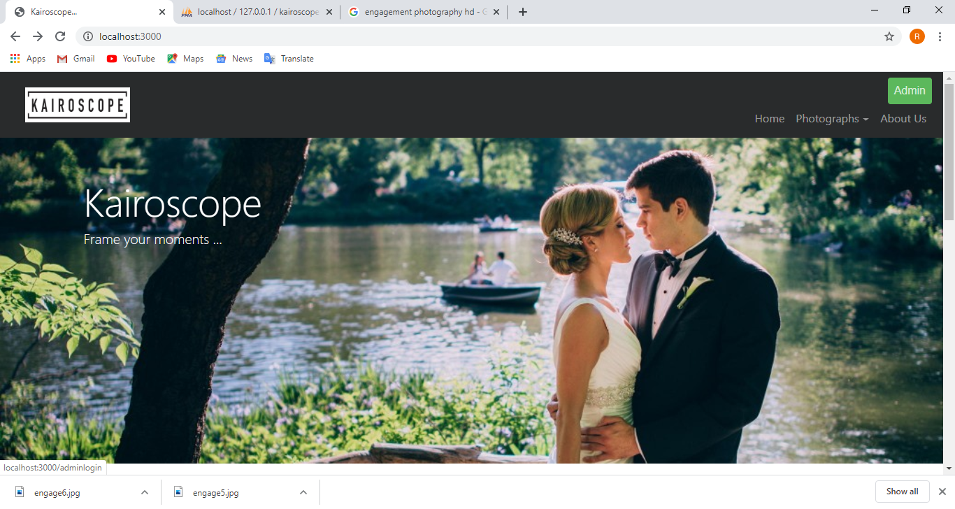



When you click on admin button it’ll redirect to ADMIN LOGIN page.(below image)

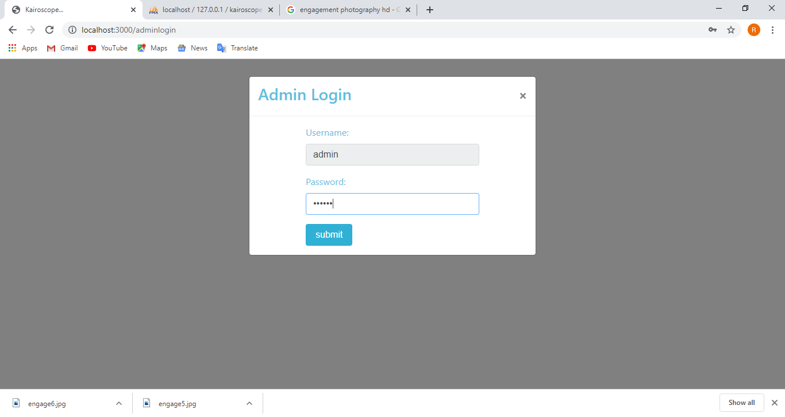

Here, we are trying to show you the action when admin enter wrong/invalid credentials.

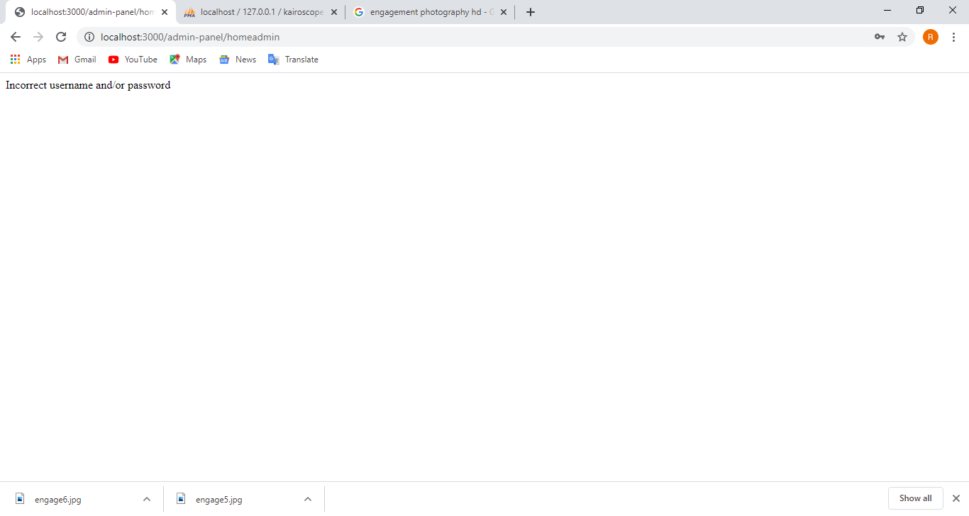

Edit Cost

In the below image you can see the event cost of pre-wedding is 10000.

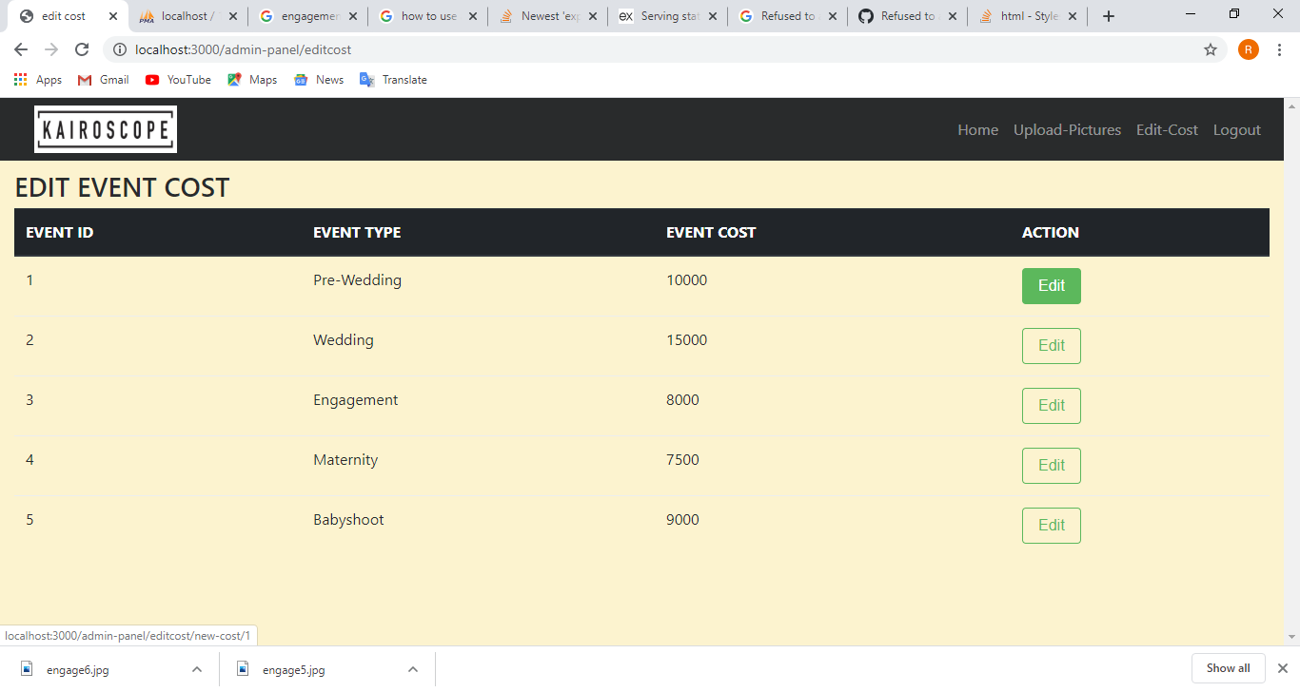

If we want to change the cost of any event just click to the edit button it’ll redirect to edit cost page to change the cost.

The admin then enter the event,old cost and new cost.

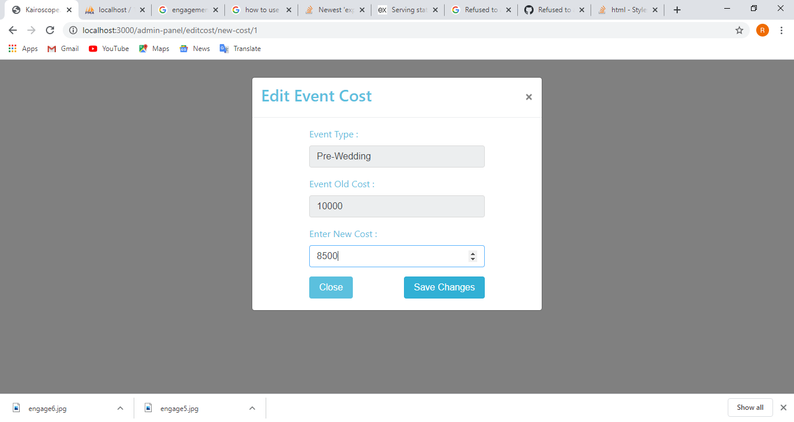

Here you can see the cost had been updated to 8500.

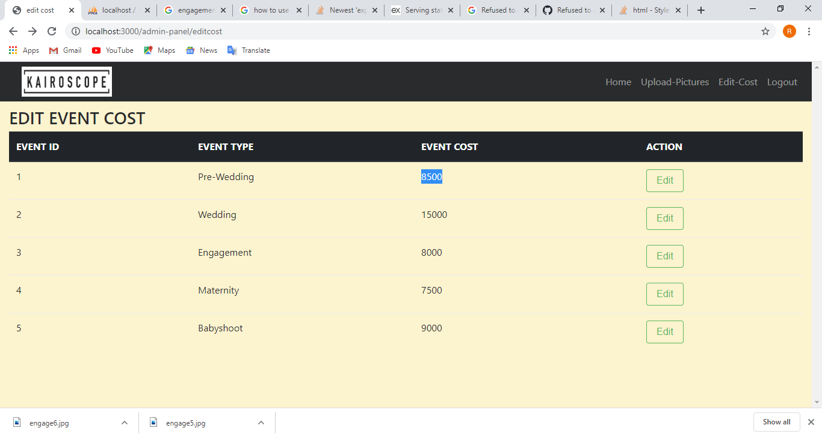

The below link is the source code of out project

<https://drive.google.com/open?id=1EekKBTpfylLugI6JHCv2d8KQUAZUnyu9>